### M E M O R A N D U M

**ADDENDUM #1**

**IFB# 23-004**

**City of Fairburn**

**Golightly Street Pedestrian Improvements Project**

**Questions & Responses:**

1. Can you please provide drawings or cut sheets for the brand or specs of lighting poles & fixtures- to include the service point- that you would like to use on this project?

**Response:**

The intent is for the lights to match the existing pedestrian lighting installed on the City of Fairburn Downtown Streetscape Project. The product information for these lights have been attached for reference. The City will accept these lights or an approved equal.

The service point will be the existing pole and transformer located at the red circle noted below.

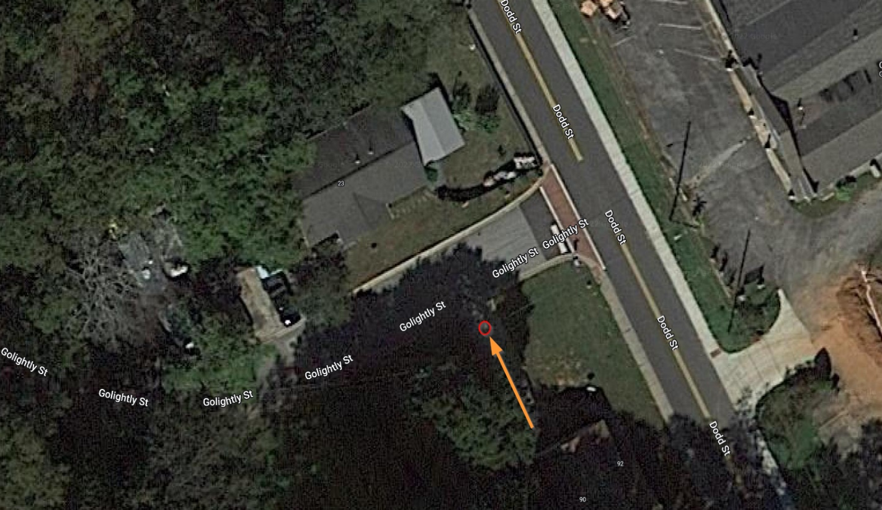

1. Will the City add an item for traffic control on base bid & alternates?

**Response:**

No.

1. Will the City add an item for grading complete?

**Response:**

No.

1. Who is in charge for paying testing?

**Response:**

Control and testing of materials will be the Contractors' responsibility for all mix provided in accordance with sections 106, 430, 441, 500 and related special provisions of the Georgia Department of Transportation Standard Specifications. The cost of such testing shall be included in the unit price of the material being used, and no additional compensation will be made.

1. Will the city add an item for sidewalk removal?

**Response:**

No, any existing sidewalk removal required should be captured in the Grading Complete line item.

1. Will the City award base on base bid or including alternate(s)?

**Response:**

The Contract will be awarded to the lowest responsive and responsible bidder whose bid will be most advantageous to City of Fairburn, price and other factors considered to include but not limited to Add Alternates.

1. Can you explain the permit require for demolition

Response:

No separate permit is required for the proposed demolition activities. All work proposed work will be authorized by the executed Contract and the Notice to Proceed (NTP) with Construction.

1. Is it required to have message boards at the job?

**Response:**

No.

1. Is it anticipated any utility relocation. if yes, who is responsible for paying and for coordination?

**Response:**

None is anticipated. However, if required it will be the responsibility of the successful Contractor at no additional cost to the City.

1. Will the city add an item for relocate chain link fence shown on CD102?

**Response:**

No, this should be captured in the line item of the improvements required at that location.

**End of Addendum**